
Daffodil International University
Department of Software Engineering

Project Proposal
Healthcare Management System
Course Name: Capstone Project
Course Code: SE 133

Submitted to:
Khalid Masum
Lecturer
Department of Software Engineering
Daffodil International University

Submitted by:
Students from section 44-J2
Name | Registration Number
Zunait Hossain Ratul (Leader) | 251-35-362*
Arvin yefat orin | 251-35-571
Md Ridoy Ali | 251-35-582
Musfiqur Rahman Shabuj | 251-35-090

Date of Submission: December 02, 2025

Table of Contents (Clickable)

Introduction

Use Case Diagram

Functional Requirements

Non-Functional Requirements

Requirements Priority Summary

Data Design

System Constraints

Challenges

Development Plan & Timeline

Deliverables

Future Enhancements

GitHub Links

1. Introduction

Problem Statement
Small clinics and healthcare centers in resource constrained environments face significant operational challenges due to reliance on paper-based record keeping systems. These manual processes lead to:
- Inefficiency: Time-consuming patient registration and data retrieval
- Data Loss Risk: Physical records are vulnerable to damage, loss, or misplacement
- Scheduling Conflicts: Manual appointment booking often results in double-bookings
- Billing Errors: Manual calculations increase the risk of financial discrepancies
- Limited Accessibility: Patient history is difficult to track across multiple visits
These challenges reduce operational efficiency, increase administrative burden, and compromise the quality of patient care.

1.2 System Overview
The Healthcare Management System (HMS) addresses these challenges by providing a CLI-based application built in C to streamline operations in small clinics. The system manages patient records, doctor schedules, appointments, and billing digitally, replacing paper-based systems.
Key Features:
- Patient and doctor information management
- Appointment scheduling with conflict prevention
- Billing and payment tracking
- Role-based access control
- Data backup and restore

1.3 Project Scope
In Scope:
- Patient registration and records management
- Doctor profile management
- Appointment scheduling
- Billing and payment tracking
- User authentication with role-based access
- Basic reporting
- Data backup and restore functionality

Out of Scope:
- Network/LAN capabilities
- Medical imaging and Lab test integration
- Insurance processing and claims
- Pharmacy and Inventory management
- SMS/Email notifications
- Web or mobile interface
- Multi-user concurrent access

1.4 User Roles & Permissions
HMS supports three user roles with file-based data storage:
Role | Responsibilities
Administrator | User management, doctor profiles, reports, backup
Doctor | View schedule, patient records, add notes
Receptionist | Patient registration, appointments, billing

Environment:
- Cross-platform CLI

System Requirement:
- Architecture: x86, x64, arm
- OS: Windows, linux, macOs
- Storage: 100MB minimum
- RAM: 256MB minimum

1.5 Stakeholders
The Hospital Management System involves multiple stakeholders, each with distinct roles and interests in the project's success:

1.5.1 Primary Stakeholders
Healthcare Clinic Staff:
- Interest: Streamlined daily operations, reduced administrative burden
- Impact: Direct users who rely on the system for patient registration, appointment scheduling, and billing
- Needs: User-friendly interface, reliable performance, minimal training requirements
Clinic Administrators:
- Interest: Operational efficiency, accurate reporting, financial tracking
- Impact: Decision-makers who use system reports for clinic management
- Needs: Comprehensive reports, user management capabilities, data backup features
Doctors:
- Interest: Quick access to patient information, efficient schedule management
- Impact: Medical professionals who need patient history for consultations
- Needs: Easy patient record access, clear daily schedule view, minimal time investment
Receptionists:
- Interest: Simplified patient registration and appointment management
- Impact: Front-desk staff handling majority of system interactions
- Needs: Fast search capabilities, conflict-free appointment scheduling, straightforward billing

1.5.2 Secondary Stakeholders
Patients:
- Interest: Accurate record-keeping, reduced waiting times, proper billing
- Impact: Indirect beneficiaries through improved clinic services
- Needs: Data privacy, accurate medical history, transparent billing
Project Development Team:
- Interest: Successful project completion, learning experience, portfolio addition
- Impact: Students responsible for design, development, and deployment
- Needs: Clear requirements, manageable scope, technical support
Academic Supervisors:
- Interest: Educational objectives met, quality capstone project
- Impact: Faculty evaluating project success and student learning
- Needs: Proper documentation, adherence to best practices, timely completion
Future Developers/Maintainers:
- Interest: Maintainable codebase, comprehensive documentation
- Impact: Those who may extend or modify the system
- Needs: Clean code, detailed comments, technical documentation
IT Support/Technical Staff:
- Interest: Easy system deployment, troubleshooting capabilities, stable performance
- Impact: Personnel responsible for installation, configuration, and ongoing technical support
- Needs: Clear installation instructions, system requirements documentation, diagnostic tools, minimal dependencies

2. Use Case Diagram
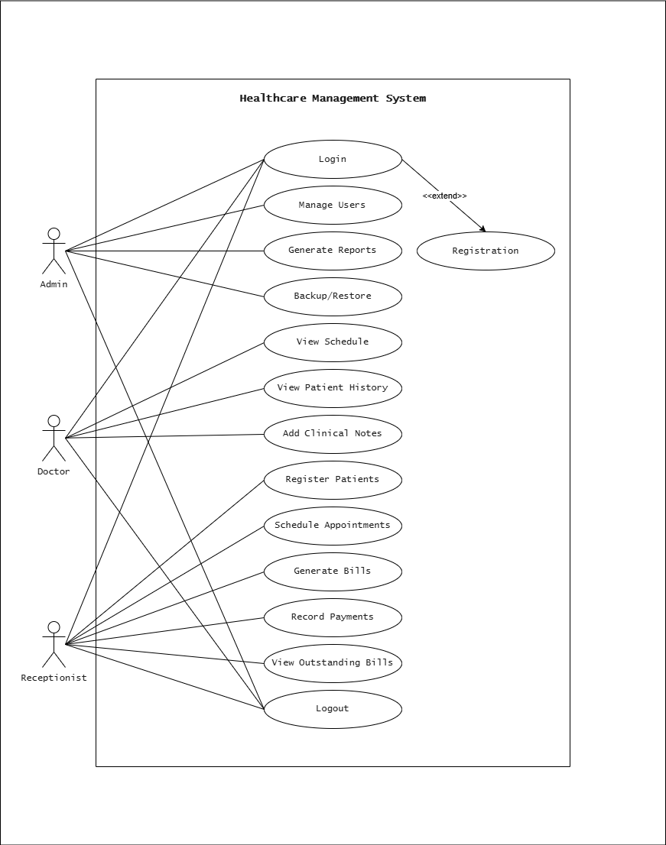

2.1 System Modules
Healthcare Management System
├── Authentication Module
├── Patient Management Module
├── Doctor Management Module
├── Appointment Management Module
└── Billing Module

3. Functional Requirements

3.1 Authentication Module:
FR-101: User Login
- As a system user
- I want to log in securely with username and password
- So that I can access role-specific functions

FR-102: Password Management
- As a logged-in user
- I want to change my password
- So that I can maintain account security

FR-103: System Logout
- As a logged-in user
- I want to securely logout from the system
- So that my session is terminated and data is protected

FR-104: View System Info
- As a user
- I want to view developer and system details
- So that I can see project information and credits

3.2 Patient Management Module:
FR-201: Register New Patient
- As a receptionist
- I want to register patients with demographic and medical information
- So that their records are available for healthcare services

FR-202: Update Patient Information
- As a receptionist
- I want to modify patient demographic information
- So that records remain current and accurate

FR-203: Search Patients
- As a receptionist
- I want to search patients by name, ID, or phone number
- So that I can find specific records even if I don't know the exact ID

FR-204: View Patient Profile
- As a receptionist or doctor
- I want to view complete patient information and appointment history
- So that I can provide appropriate care and service

FR-205: Patient Visit History
- As a doctor or receptionist
- I want to view chronological history of patient visits
- So that I can track treatment progress over time

3.3 Doctor Management Module:
FR-301: Manage Doctor Profiles
- As an administrator
- I want to add and update doctor information
- So that doctor schedules and fees are accurate

FR-302: View Doctor List
- As a receptionist or administrator
- I want to view all active doctors with specializations
- So that I can assist patients in doctor selection

3.4 Appointment Management Module:
FR-401: Schedule Appointment
- As a receptionist
- I want to book appointments with date and time
- So that patient visits are organized and double-booking is prevented

FR-402: View Appointments
- As a receptionist or doctor
- I want to view appointments by date or doctor
- So that I can manage schedules effectively

FR-403: Cancel Appointment
- As a receptionist
- I want to cancel appointments with reason
- So that slots become available and records are updated

FR-404: Doctor's Daily Schedule
- As a doctor
- I want to view my appointments for selected date
- So that I can prepare for consultations

FR-405: Reschedule Appointment
- As a receptionist
- I want to change appointment date or time
- So that I can accommodate patient requests

3.5 Billing Module:
FR-501: Generate Bill
- As a receptionist
- I want to create bills for consultation fees
- So that patients are charged accurately

FR-502: Record Payment
- As a receptionist
- I want to record payment amount and method
- So that billing records are complete

FR-503: Track Unpaid Bills
- As a receptionist
- I want to view all unpaid and partially paid bills
- So that I can follow up on pending payments

3.6 Reporting Module:
FR-601: Patient Registration Report
- As an administrator
- I want to generate patient registration statistics
- So that I can track clinic growth

FR-602: Revenue Summary Report
- As an administrator
- I want to view total revenue collected
- So that I can monitor financial performance

FR-603: Appointment Statistics
- As an administrator
- I want to generate appointment statistics by doctor or date
- So that I can analyze clinic utilization

FR-604: Export Patient List
- As an administrator
- I want to export the patient list to a CSV/text file
- So that I can use the data in other applications

4. Non-Functional Requirements
NFR-1: Performance
- System responds quickly to user inputs
- Search operations complete in reasonable time
- No noticeable delays in operations
NFR-2: Security
- Username and password authentication required
- Simple XOR Cipher for passwords
- Role-based access control enforced
NFR-3: Usability
- Clear numbered menu system
- Informative error messages
- Confirmation prompts for critical operations
- Consistent interface layout
NFR-4: Reliability
- Input validation prevents invalid data
- Error handling prevents crashes
- Backup and restore functionality available
NFR-5: Maintainability
- Modular code structure
- Well-commented code
- Functions kept reasonably short
- Clear README with compilation instructions

5. Requirements Priority Summary

ID | Description | Priority
FR-101 | User Login | Must Have
FR-102 | Password Management | Should Have
FR-103 | System Logout | Must Have
FR-104 | View System Info | Should Have
FR-201 | Register New Patient | Must Have
FR-202 | Update Patient Information | Must Have
FR-203 | Search Patients | Must Have
FR-204 | View Patient Profile | Must Have
FR-205 | Patient Visit History | Could Have
FR-301 | Manage Doctor Profiles | Must Have
FR-302 | View Doctor List | Must Have
FR-401 | Schedule Appointment | Must Have
FR-402 | View Appointments | Must Have
FR-403 | Cancel Appointment | Must Have
FR-404 | Doctor's Daily Schedule | Must Have
FR-405 | Reschedule Appointment | Should Have
FR-501 | Generate Bill | Must Have
FR-502 | Record Payment | Must Have
FR-503 | Track Unpaid Bills | Should Have
FR-601 | Patient Registration Report | Could Have
FR-602 | Revenue Summary Report | Should Have
FR-603 | Appointment Statistics | Could Have
FR-604 | Export Patient List | Could Have

6. Data Design

6.1 Core Data Entities
User: UserID, Username, Password, Role, Full Name, Contact
Patient: PatientID, Full Name, DOB, Gender, Contact, Address, Blood Group, Allergies
Doctor: DoctorID, Full Name, Specialization, Contact, Consultation Fee, Available Days
Appointment: AppointmentID, PatientID, DoctorID, Date, Time, Status, Reason
Bill: BillID, PatientID, AppointmentID, Amount, Payment Status, Payment Method

6.2 Validation Rules
- Contact Number: Exactly 11 digits
- Name: Alphabets and spaces only, min 3 characters
- Password: Minimum 6 characters, case-sensitive
- Age: 0-120 years
- Appointment Date: Must be today or future date
- Blood Group: Restricted to valid set {A+, B+, ...}

7. System Constraints
- Single user system (no concurrent access)
- File-based storage only (no database)
- Console based interface (no GUI)
- Not HIPAA/healthcare compliant
- Platform-dependent file paths (Windows/Linux)

8. Challenges

8.1 Technical Challenges
- Data Consistency: Managing file pointers and ensuring data integrity without a relational database.
- Memory Management: Efficiently handling patient records within limited RAM using C structures.
- Input Validation: Robustly sanitizing all user inputs to prevent system crashes.
- Cross-Platform Compatibility: Ensuring the CLI application works correctly on Windows and Linux environments.

8.2 Operational Challenges
- Time Constraints: Completing full-stack CLI implementation within the 8-week semester timeline.
- Resource Limitations: Limited to 4 developers for design, coding, testing, and documentation.

9. Development Plan

9.1 Timeline (8 Weeks)

Week | Module | Tasks
1 | Planning | SRS, design, setup
2 | Foundation | Authentication, file I/O, menu
3 | Patient Module | CRUD operations
4 | Doctor & Appointment | Management, scheduling
5 | Billing | Bill generation, payments
6 | Reports & Admin | Reports, backup
7 | Testing | Unit, integration, system tests
8 | Documentation | User manual, presentation

9.2 Testing Approach
- Unit Testing: Individual function testing
- Integration Testing: Module interaction testing
- System Testing: End-to-end workflow testing
- User Acceptance: Validate against requirements

10. Deliverables

Software
- Source code (.c and .h files)
- Compiled executable
- Makefile

Documentation
- Software Requirements Specification
- README.md with setup instructions

11. Future Enhancements
The following features are planned for future versions to expand system capabilities:
- Database Integration: Migrate from file-based storage to SQL database for better scalability.
- Graphical User Interface (GUI): Develop a desktop UI using C# or Java for better usability.
- Network Support: Enable multi-user access over LAN for simultaneous operations.
- SMS Notifications: Integrate API to send appointment reminders to patients.
- Prescription Printing: Auto-generate printable prescriptions from doctor notes.

12. GitHub Links

Leader's Repository
Repository: Hospital-Management-System (Main)

Direct Link: https://github.com/AmiValoHoteChai/Hospital-Management-System
Leader: Zunait Hossain Ratul (AmiValoHoteChai)

Team Member’s Forked Repositories
- Orin: https://github.com/251-35-571-rgb/Hospital-Management-System.git

- Ridoy: https://github.com/Ridoy1237/Hospital-Management-System.git

- Mushfik: https://github.com/musigit2004/Hospital-Management-System.git

Note: All team members will fork the leader's repository and contribute via pull requests following Git collaborative workflow. The main repository links is provided as both a hyperlink and direct link.

EOF (End of File)

